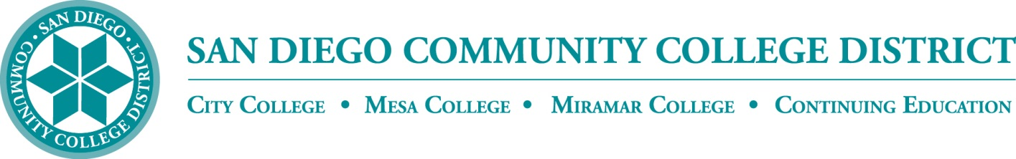

Policy 6100 (NUMBER?)

June 21, 1995

**Career Technical Education (CTE) CUSTOMER SERVICE**

Instructional experience in many CTE courses is gained through the repair, fabrication, construction, or provision of services in an educational laboratory setting under the direct supervision of District certificated instructors. This valuable experience would be limited if projects were restricted to District-owned or student-owned property only. Therefore, in order to enhance applied educational experiences, CTE programs may provide services to the general public in accordance with the guidelines set forth in this policy.

Repairs, fabrications, constructions, or provision of services to customers as a part of CTE courses, degrees or certificates are authorized under the following conditions:

1. Within the context of this policy, a “customer” means any person who receives services authorized under this policy, including students who receive services other than as a part of their regular instructional program.
2. All projects or services authorized under this policy shall be accepted on the merit of their educational value to the curriculum involved as determined by the offering college/center.
3. Costs to the District incurred as part of the service shall be recovered in the form of charges to the customers.
   * Costs derived from use of District stock supplies and purchases from outside vendors shall be itemized and charged to the customer.
   * Costs which are not convenient to itemize shall be charged in the form of a service fee in accordance with BP 3300. Service fee schedules for like services shall be uniform District wide.
   * All costs defined herein shall be charged to all customers for whom work/services are performed.
4. A record of all service performed will be maintained using standard Work Order or Service Request forms (check the title of the form or process) which, as a minimum, contain:
   * A District disclaimer of liability for damage or loss which may result from, or during the work or service.
   * The customer's signature acknowledging that the work is performed by students in an educational laboratory and agreeing to hold the District harmless for any damage, loss or injury which may result from the work/service. (This does not prohibit replacement or repair of damage done by students during the work/service. If said repair or replacement is justified, as determined by the instructor and approved by the appropriate dean, costs may be charged against the appropriate campus/center budget.)

SUPERSEDES

Policy C-8400 - 07/01/69 Policy 6100 - 08/12/82